**Apple store review analysis**

**Project context;** Data set that covers information on apps available in apple app store

**Stakeholder:** Web developer, an aspiring app developer who needs data driven insights to decide which app to develop; Questions, what app category are most popular, what pricing should I set for the app, how can I maximize user ratings

**Business objective:** Find the best app to develop

**Source of data:** Kaggle (Apple store for all the apps gives information on --- and each application description)

**Analysis tool: SQLITE**

**Process of analysis:** Downloaded the data in excel format, Divided the app description files into smaller chunks because SQL has a limited amount of 4MBs it can load

**SQL ANALYSIS;**

1. **Joined the description data into one file**

**CREATE TABLE Combined_appleStore_descriptions AS**

**SELECT * FROM appleStore_description1**

**UNION ALL**

**SELECT * FROM appleStore_description2**

**UNION ALL**

**SELECT * FROM appleStore_description3**

**UNION ALL**

**SELECT * FROM appleStore_description4**

1. **Checked if the data matches all the entries after joining**

**--Check the number of unique appsAppleStore to see if there is any descrepancies**

**SELECT COUNT(DISTINCT id) As uniq_apps**

**FROM AppleStore**

**"7197"**

**SELECT COUNT(DISTINCT id) As uniq_apps**

**FROM Combined_appleStore_descriptions**

1. **--Check for any missing values in key fields**

**SELECT COUNT(*) As missing_values**

**FROM AppleStore**

**WHERE track_name is NULL or user_rating is null or prime_genre is null**

**"0"**

**SELECT COUNT(*) As missing_values**

**FROM Combined_appleStore_descriptions**

**WHERE app_desc is NULL**

**"0"**

**--Find out the number of apps per genre**

**SELECT prime_genre, COUNT(*) As number_of_apppergenre**

**FROM AppleStore**

**GROUP BY prime_genre**

**ORDER BY number_of_apppergenre DESC**

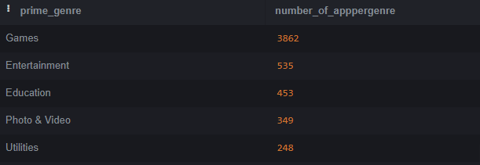

**--Get an overview of apps rating**

**SELECT**

**MIN(user_rating) As min_rating,**

**MAX(user_rating) As max_rating,**

**AVG(user_rating) As avg_rating**

**from AppleStore**

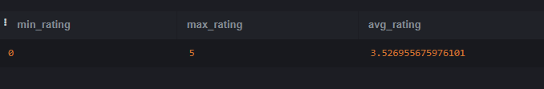

**\*\*DATA ANALYSIS\*\***

**--Determine whether paid apps have higher ratings from app**

**SELECT CASE**

**when price >0 THEN 'Paid'**

**ELSE 'Free'**

**END As app_type, avg(user_rating) As avg_rating**

**FROM AppleStore**

**GROUP BY app_type**

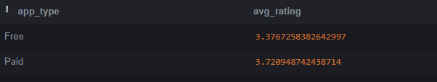

**--check if apps with more languages have higher rating**

**SELECT CASE**

**WHEN lang_num < 10 THEN '< 10 languages'**

**WHEN lang_num BETWEEN 10 AND 30 THEN '10-30 languages'**

**ELSE '> 30 languages'**

**end As language_bucket, avg(user_rating)**

**FROM AppleStore**

**GROUP by language_bucket**

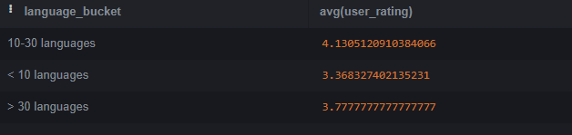

**--Check which genre has the highest ratingAppleStore**

**SELECT prime_genre, avg(user_rating) as avg_rating**

**FROM AppleStore**

**GROUP BY prime_genre**

**ORDER BY avg_rating Asc**

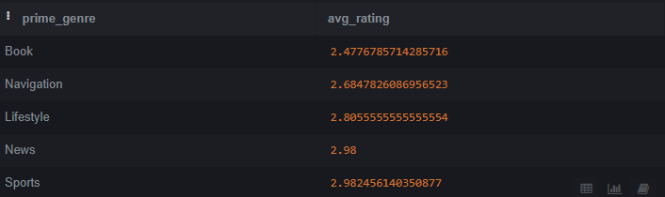

**--Check if there is correlation between length of app description and user ratingAppleStore**

**SELECT CASE**

**WHEN length(b.app_desc)< 500 THEN 'short'**

**WHEN length(b.app_desc) BETWEEN 500 AND 1000 THEN 'Medium'**

**ELSE 'Long'**

**end As description_bucket, avg(a.user_rating)As avg_rating**

**FROM AppleStore as a**

**JOIN Combined_appleStore_descriptions as b**

**on a.id = b.id**

**GROUP BY description_bucket**

**ORDER BY avg_rating**

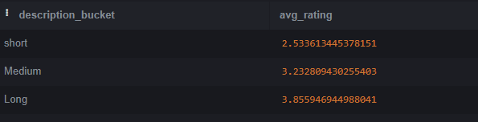

**--Check the top rated app per genreAppleStore**

**SELECT**

**prime_genre,**

**user_rating,**

**track_name**

**FROM (**

**SELECT**

**prime_genre,**

**user_rating,**

**track_name,**

**rank() over(partition by prime_genre ORDER BY user_rating DESC, rating_count_tot DESC) as rank**

**FROM AppleStore) As a**

**WHERE a.rank=1**

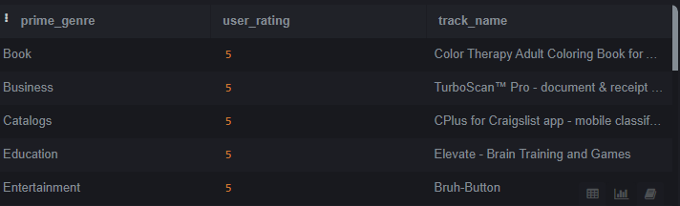

**RECOMMENDATIONS**

Paid apps have higher ratings than free apps which maybe because users of paid apps have higher engagement rates due to high perceived values and so we can tell our client if the quality of app is high they should consider charging.

Apps supporting multiple languages 10 to 30 have higher rating it’s not number of languages your app support but the focus should be on the right language

Finance and book apps have low rating; suggesting user needs are not being fully met in these genres. So developing a relevant and meaningful app may bring more users

The length of app description has a positive correlation with user rating which implies user appreciate a clear understanding of app features and capabilities before deciding to use the app. So, a well-crafted app description can set clear expectation and eventually increase satisfaction of users

Target rating’; On average all the apps have an average rating of 3.5 so in order to stand out from the crowd we should aim for user rating higher than 3.5

The games and entertainment genres have high volumes of apps suggesting the market maybe saturated. So, entering this space maybe challenging due to high competition, however it also suggest the high user demand in this domain